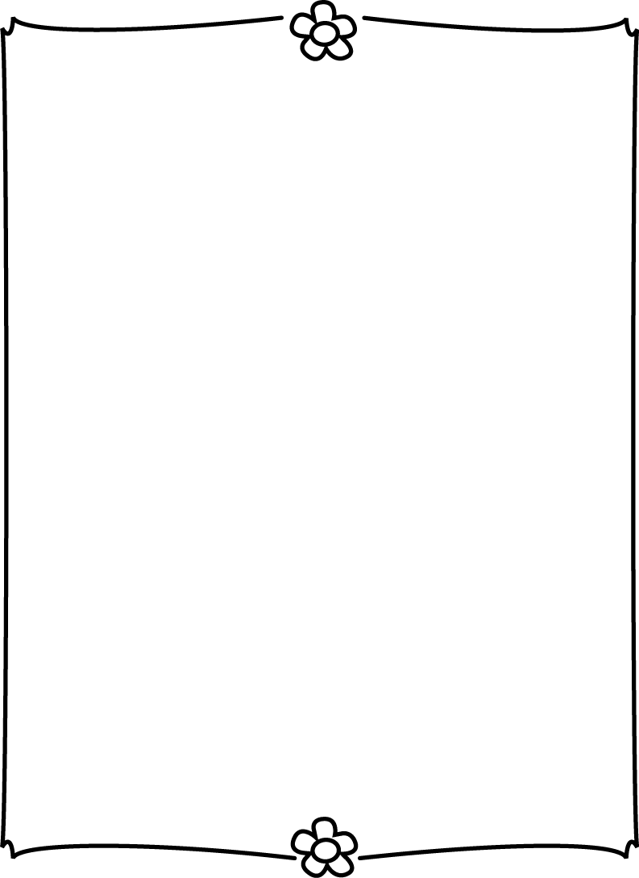

Vocabulary Words:

1. arranged- put in order or position

2. bundles- things tied or wrapped together so that they are easy to carry

3. dangerously- unsafe

4. errands- short trips to do something

5. excitedly- with strong, lively feelings

6. steady- firmly fixed, not swaying

7. unwrapped- uncovered by removing something placed around an item

8. wobbled- moved from side to side in an unsteady or shaky way

Homework:

Monday: NO SCHOOL

Tuesday: English journal, study for math test

Wednesday:  vocab page, bible- (due Friday)  
Thursday: study for spelling test Friday, math 2-1, author's purpose page  
Friday: Journals home, bible homework due, health sheet (track a few meals over the weekend)

Upcoming tests:

Tues.. Sept. 3 Math ch 1

 Fri. Sept. 5 Spelling, vocab/reading test, Memory Verse  
Fri. Sept. 12: Spelling, Memory Verse

Fri. Sept. 19: Spelling, Memory Verse

upcoming:

* *You may send in donations (monetary or items) for our Fall Family Fun Night basket!

This week we're learning:

Bible- Jesus prepares from ministry

Reading: My Rows and Piles of Coins skill: authors purpose

Phonics: vowels ou, ow, oi, oy

Grammar: Compound Sentences

Math: Chapter 1- TEST Sept 3, Ch. 2-Add to Solve Problems  
Health: Healthy Foods, hand washing, Germs   
Science:  Rocks and Earth Materials

Bible memory verse: "And a voice from heaven said, 'This is my Son whom I love; with Him I am well pleased.' Matthew 3:17

Spelling List

|  |
| --- |
| **1. copy**  **2. hope**  **3. broken**  **4. window**  **5. paint**  **6. addition**  **7. sum**  **8. ministry**  **9. compound**  **10. bundles**  **11. errands**  **12. steady**  **13. cookout**  **14. point**  **15. diet**  **16. nutrition**  **17. healthy**  **18. crystal**  **19. evaporate**  **20. observe** |
|  |
|  |
|  |
|  |
|  |
|  |
|  |
|  |
|  |
|  |
|  |
|  |
|  |
|  |
|  |
|  |
|  |
|  |
|  |

Room 126... #4 week of September 2-5